**Developing an Ecommerce Website for Sporty Shoes**

**Developer: Kamar Zaghloul**

1. **Info**

* FSD 2021 (Vodafone)
* **Developer**: Kamar Zaghloul
* **GitHub Repo**:

<https://github.com/kamarz01/Simplilearn_Phase3_Ecommerce_Sporty_Shoes>

1. **Introduction**

**Project objective:**

As a Full Stack Developer, complete the features of the application by planning the development and pushing the source code to the GitHub repository. 

**Background of the problem statement:**

Sporty Shoes is a company that manufactures and sells sports shoes. They have a walk-in store, and now, they wish to launch their e-commerce portal sportyshoes.com.

You’re asked to develop a prototype of the application. It will be then presented to the relevant stakeholders for budget approval. Your manager has set up a meeting where you’re asked to do the following:

● Presenting the specification document which has the product’s capabilities, appearance, and user interactions  
● Setting up Git and GitHub account to store and track your enhancements of the prototype   
● Explaining the Java concepts used in the project   
● Discussing the generic features of the product:  
● There will be an admin to manage the website. An administrator login will be required to access the admin page.

**The admin should be able to change his password if he wants, he should be able to:**

● Manage the products in the store including categorizing them  
● Browse the list of users who have signed up and be able to search users  
● See purchase reports filtered by date and category

1. **Project Planning**
   * + - The project is to be completed in two sprints.
       - The resources available for this project is (2):

1 Developer & 1 Tester.

**Sprint (1) will include:**

* + - * Create application design.
      * Create project skeleton.
      * Setup project configurations.
      * Create database schema.
      * Design project UI screens.
      * Implement Admin features.

**Sprint (2) will include:**

* + - * Implement Customer features
      * Create purchase report.
      * Creating documentations.
      * Pushing project to GitHub.

1. **Technologies & Concepts used in Project**
   * + - Java EE
       - Hibernate
       - Spring MVC
       - Spring Boot
       - Spring Data JPA
       - AOP
       - H2 (in-memory database)
       - HTML5
       - CSS3
       - OOP
       - Collections
       - Streams
       - Data Structures

and more...

1. **Default Data & Admin**

(username = **admin**, Passowrd = **admin**)

Auto inserted into db with other dummy data

1. **Project Structure**

The project was been created following a good design structure to separate the logic from the user interface.

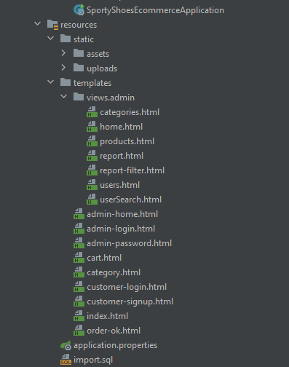

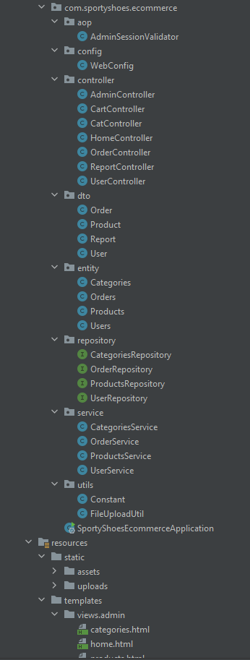

**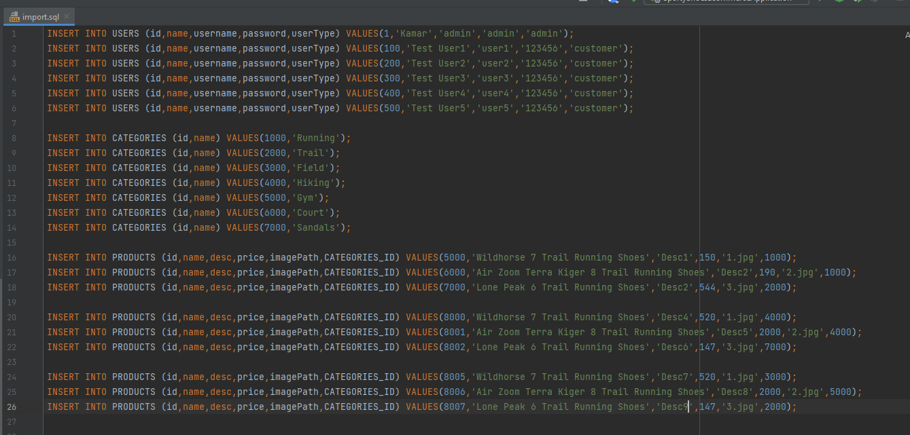**

**C:\Users\Vodafone-IoT\Pictures\Screenpresso\2022-04-01_02h57_14.png**

1. **Application Demo**

**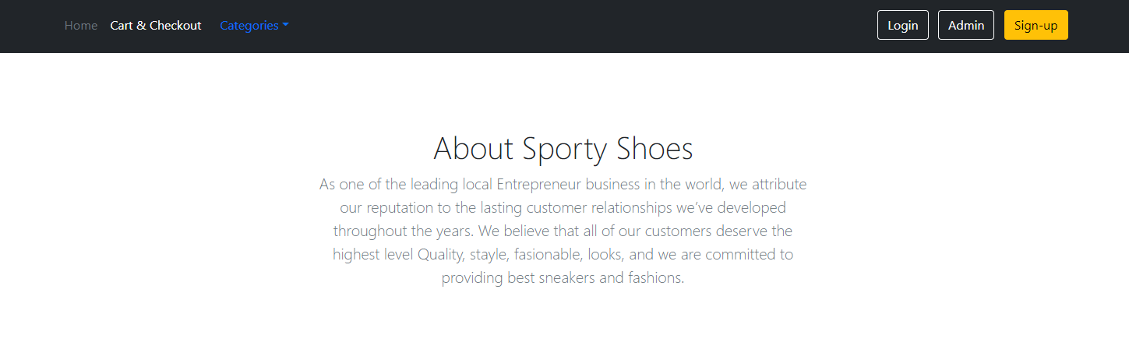**

**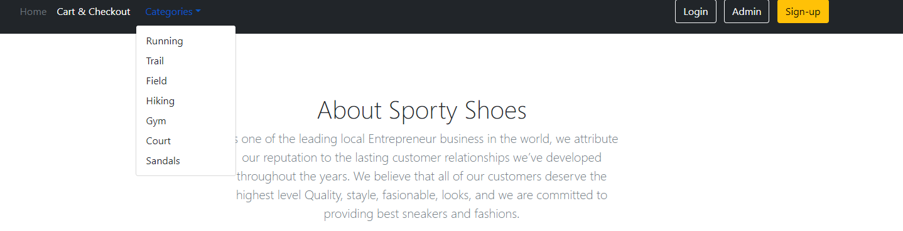**

**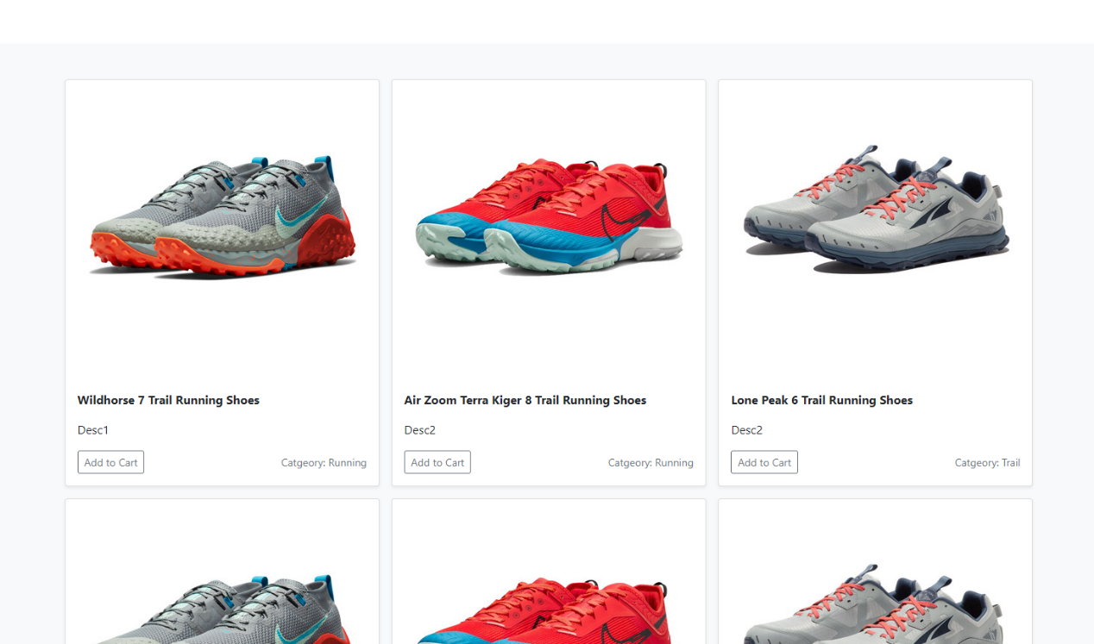**

**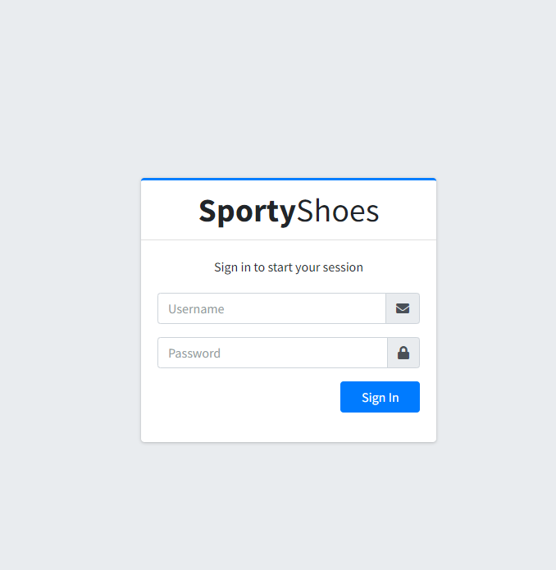**

**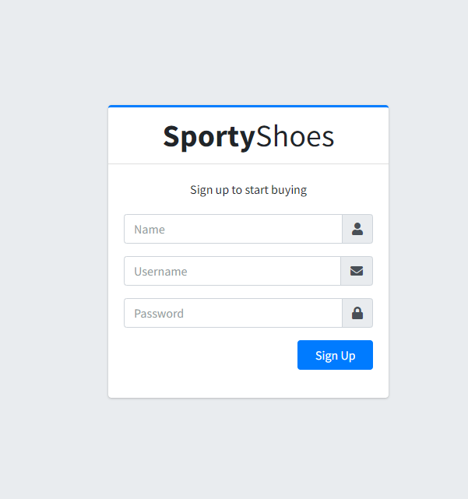**

****

**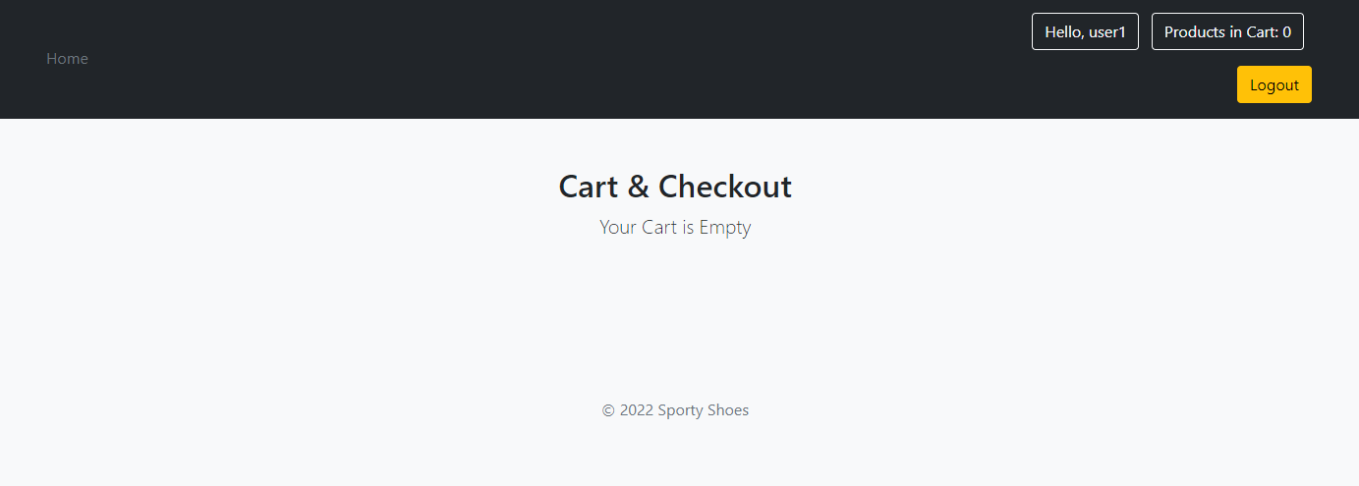**

****

**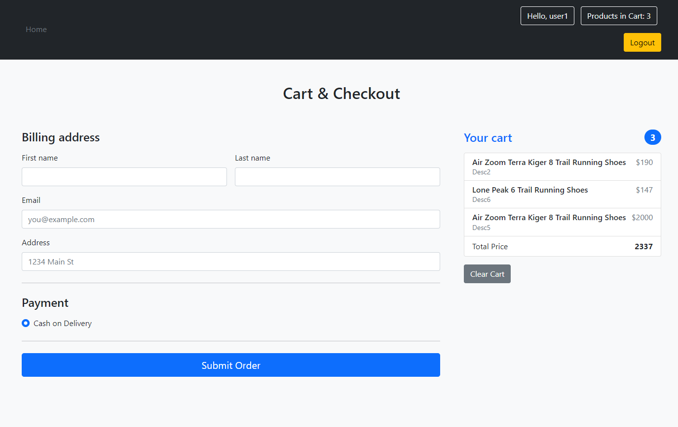**

**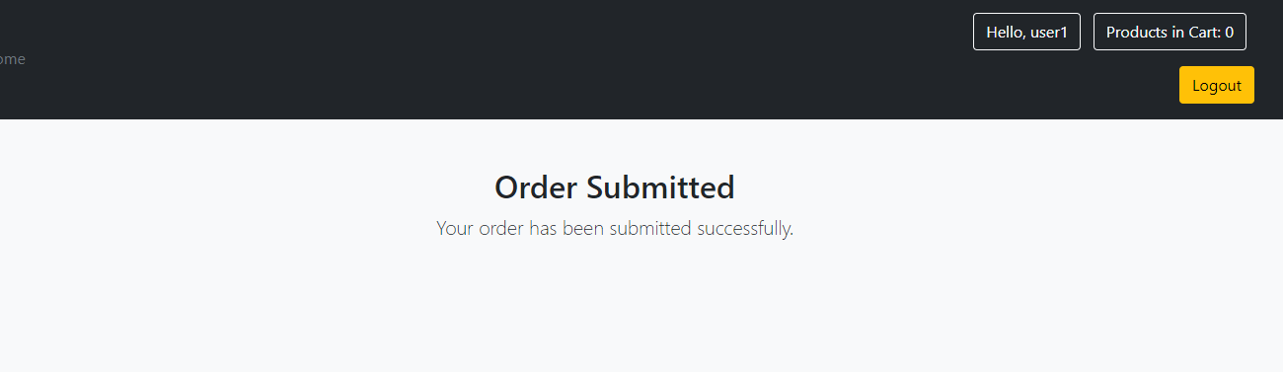**

**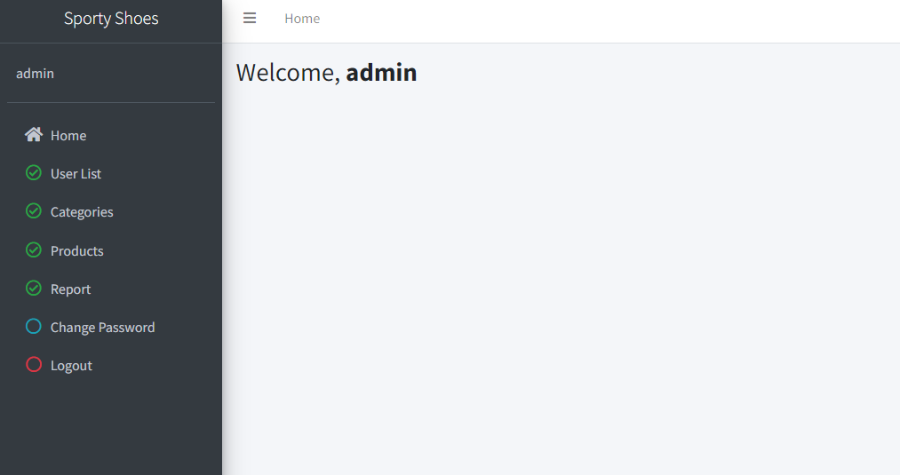**

**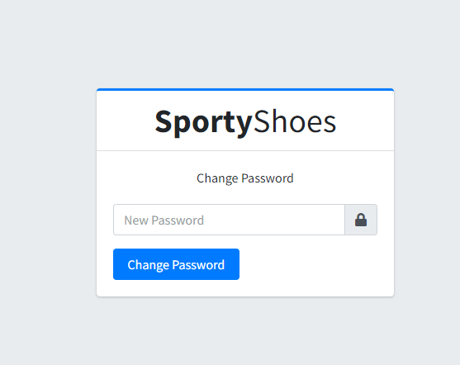**

**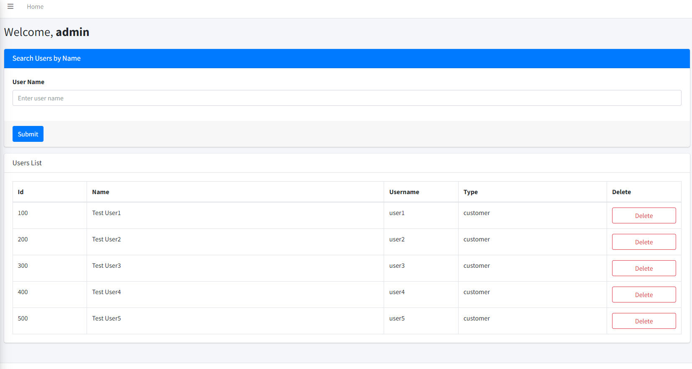**

**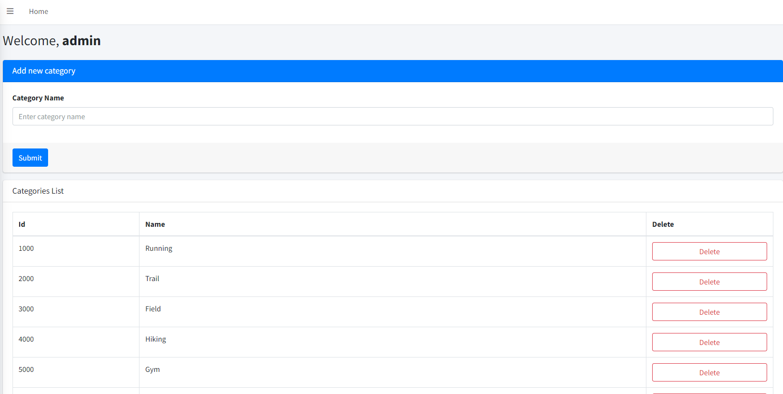**

**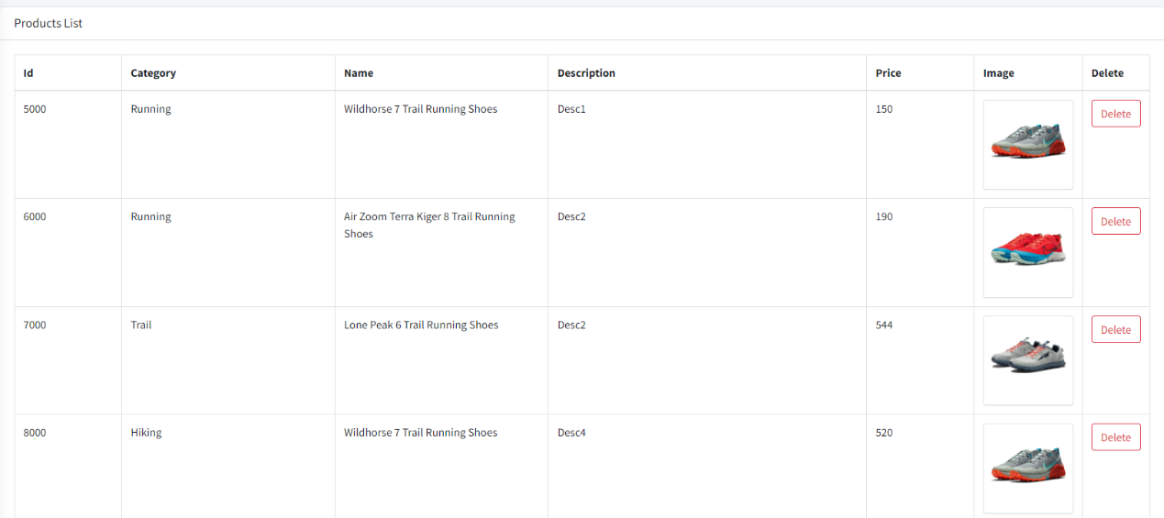**

**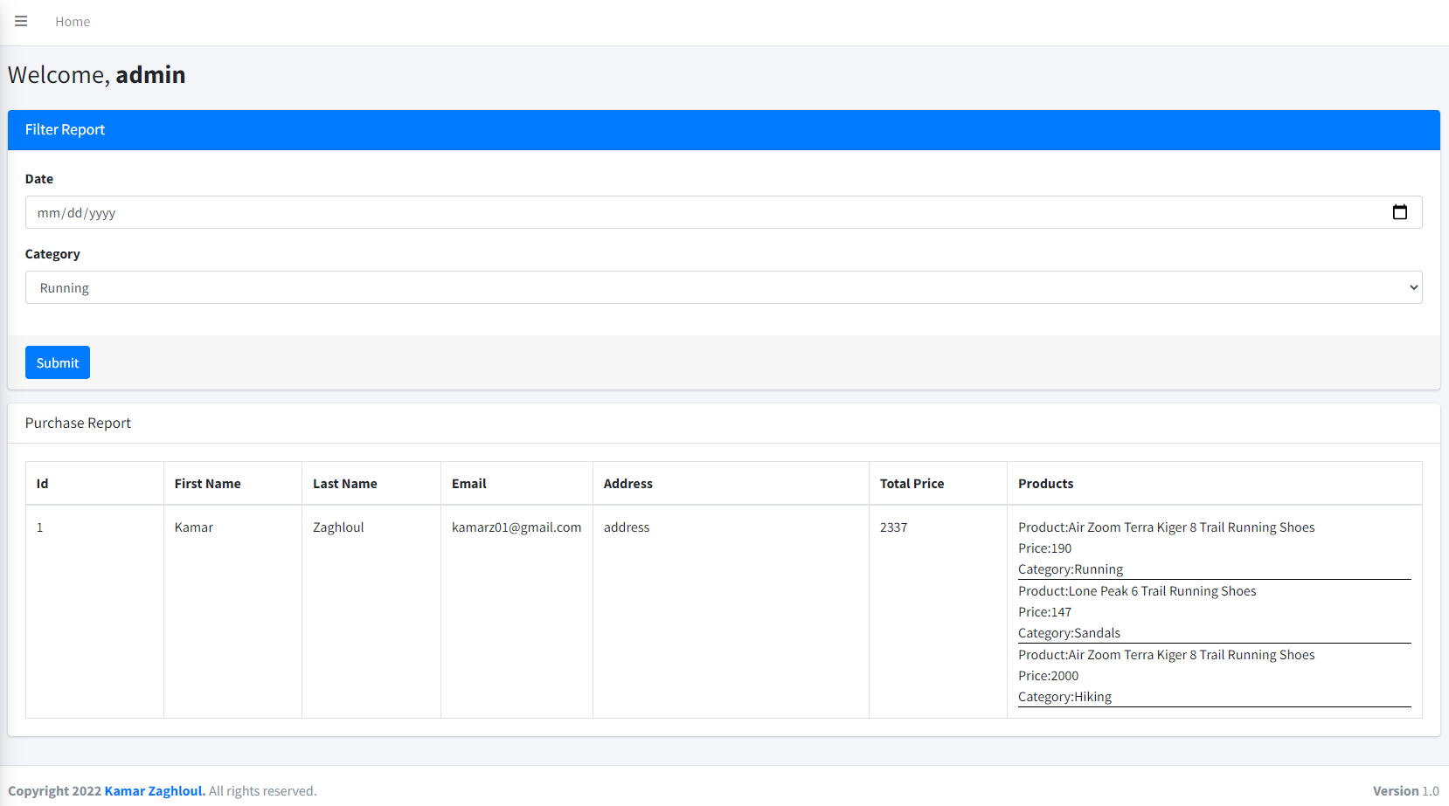**

**Rest of screenshots can be found here:**

[**https://github.com/kamarz01/Simplilearn\_Phase3\_Ecommerce\_Sporty\_Shoes/tree/main/Screenshots**](https://github.com/kamarz01/Simplilearn_Phase3_Ecommerce_Sporty_Shoes/tree/main/Screenshots)

1. **Github Repo**

<https://github.com/kamarz01/Simplilearn_Phase3_Ecommerce_Sporty_Shoes>